INSTITUTIONAL PROGRAM REVIEW 2009-10
Program Efficacy Phase, Spring, 2010

Purpose of Institutional Program Review

Welcome to the Program Efficacy phase of the San Bernardino Valley College Program Review process. Program Review is a systematic process for evaluating programs and services annually. The major goal of the Program Review Committee is to evaluate the effectiveness of programs, and to make informed decisions about budget and other campus priorities.

The Institutional Program Review Committee is authorized by the Academic Senate to develop and monitor the college Program Review process, receive unit plans, utilize assessments as needed to evaluate programs, recommend program status to the college president, identify the need for faculty and instructional equipment, and interface with other college committees to ensure institutional priorities are met.

The purpose of Program Review is to:
❑ Provide a full examination of how effectively programs and services are meeting departmental, divisional, and institutional goals
❑ Aid in short-range planning and decision-making
❑ Improve performance, services, and programs
❑ Contribute to long-range planning
❑ Contribute information and recommendations to other college processes, as appropriate
❑ Serve as the campus’ conduit for decision-making by forwarding information to or requesting information from appropriate committees

Our Program Review process is two-fold. It includes an annual campus-wide needs assessment in the fall, and an in-depth review of each program every three years that we call the Program Efficacy phase. Instructional programs are evaluated the year after content review, and every three years thereafter, and other programs are placed on a three-year cycle by the appropriate Vice President.

An efficacy team of two disinterested committee members will meeting with you to carefully review and discuss your document. You will receive detailed feedback regarding the degree to which your program is perceived to meet institutional goals. The rubric that the team will use to evaluate your program is included with this e-mail

When you are writing your program evaluation, you may contact efficacy team assigned to review your department or your division representatives for feedback and input. The list of readers is being sent to you with these forms as a separate attachment.

Forms are due back to the Committee Chairs, Efficacy Team and Division Dean by March 22, 2010.
It is the writer’s responsibility to be sure the Committee receives the forms on time.

In response to campus wide feedback that program review be a more interactive process, the committee will pilot a program efficacy that includes a review team who will interviews and/or tour a program area during the efficacy process. Another campus concern focused on the duplication of information required for campus reports. The pilot will incorporate the Educational Master Plan One-Page Summary (EMP Summary) and strive to reduce duplication of information while maintaining a high quality efficacy process. More details on the pilot can be found in the attached file.

Program Efficacy, Spring 2010

Complete and attach this cover sheet as the first page of your report.

Program Being Evaluated
Computer Science

Name of Department:
Computer Information Technology and Computer Science

Name of Division
Mathematics Business and Computer Technology

Name of Person Preparing this Report Extension
Roger Powell 8910

Name of Department Members Consulted
Cristian Racataian

Name of Efficacy Team
Carmen Rodriguez, Sue Crebbin

Program Review Committee Representatives
Teri Strong, Michael Mayne

Work Flow | Due Date | Date Submitted
Date of initial meeting with department | Click here to enter text. | Click here to enter text.
Final draft sent to the dean | Click here to enter text. | Click here to enter text.
Report submitted to Program Review Team | Click here to enter text. | Click here to enter text.
Meeting with Review Team | Click here to enter text. | Click here to enter text.

Staffing
List the number of full and part-time employees in your area.
Classification | Number Full-Time | Number Part-time, Contract | Number adjunct, short-term, hourly
Managers | 1 | 0 | 0
Faculty | 0.2 | 0 | 2
Classified Staff | 0 | 0 | 0
Total | 1.2 | 0 | 2

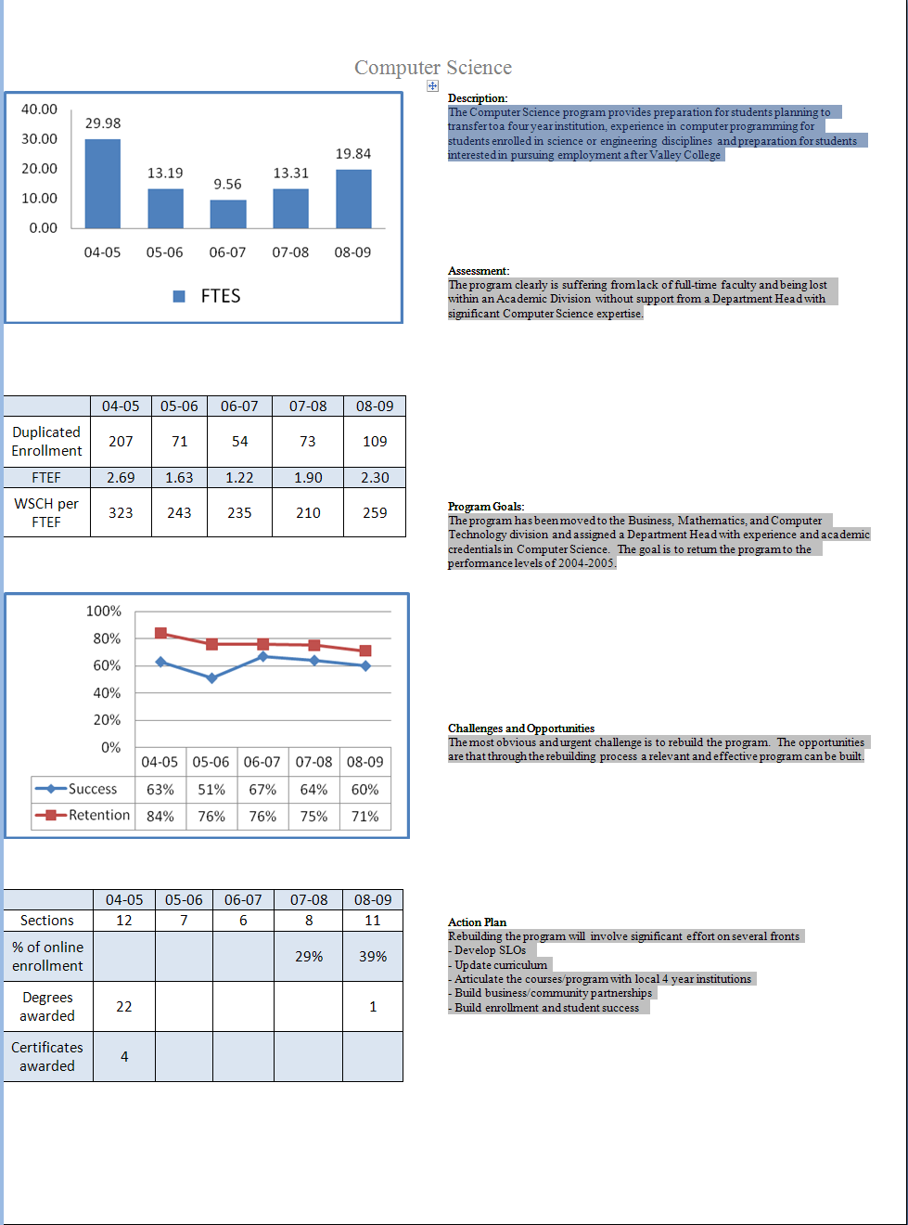
Part I. Questions Related to Strategic Initiative: Access

Use the demographic data provided to describe how well you are providing access to your program by answering the questions below.

Demographic Information
Gender (%) | Program Demographics | College Demographics
Male | 75.9% | 43.04%
Female | 24.1% | 56.26%
Ethnicity (%)
African-American | 14.5% | 18.39%
Caucasian (white) | 21.7% | 22.63%
Hispanic | 39.8% | 45.51%
Asian | 13.3% | 4.63%
Disability | No data provided
Other

Does the program population reflect the college’s population? Is this an issue of concern? If not, why not? If so, what steps are you taking to address the issue?

There are significant disparities in every category except for the enrollment rate of Caucasian students which at 21.7% for the program is essentially equal to the general College 22.63%. For the remaining categories, the plans are as follows: Gender discrepancy - Computer Science like many other Science and Mathematics based programs has a higher ratio of Male to Female students and there is a similar gender distribution amongst working professionals. The Computer Science program has plans to address this by adding a Computer Science strand to the Empowering Women in Math and Science program, actively searching for a female adjunct instructor, and working with Industry groups such as GirlGeeks.org and Women in Open Source Software. African-American Discrepancy - the comments related to levels of participation for women is similar to African-Americans. The Science Technology Engineering and Math (STEM) initiative documents this situation in both college enrollment and employment. The plan to address this are similar to the gender inequity concern, adding a Computer Science strand to the Empowering Men in Mathematics, engage community organizations such as Priscilla’s Helping Hands. There is already an African-American adjunct faculty in Computer Science. Hispanic Discrepancy – The situation here is essentially the same as the gender and other under-represented groups and similar outreach efforts with groups that are appropriate to the Hispanic community are planned.

Pattern of Service
How does the pattern of service and/or instruction provided by your department serve the needs of the community? Include as appropriate hours of operation/pattern of scheduling, alternate delivery methods, weekend instruction/service.

The number of course offerings have been limited due to low enrollment which is attributed to the loss of any full-time faculty (discussed below). An effort to maintain minimum acceptable enrollment levels and avoid class cancellations caused practically all courses to be offered during the evening. This further eroded the program. Starting with this semester (Spring 2010) a day time program has been restarted. The plan is to create an alternating sequence of courses such that students who can attend both day and evening course will be served. The creation of online sections was begun but little support was available. The Department has begun cooperation with CSUSB leading towards shared access to CSUSB virtual lab resources that will strengthen the online program. The addition of online will strengthen the program.

Part II: Questions Related to Strategic Initiative: Student Success
Provide a brief analysis of the data and narrative from the program’s EMP Summary and discuss what it reveals about your program.
This is a program in need of a lot of attention. The enrollment trends show a steady decline that began when the only full-time faculty member left and the decision was made not to replace her. The absence of full time faculty lead to an overall decline in the program. SLOs were not created, curriculum was not updated, and articulation with CSUSB was not pursued. The Department Head has begun a rehabilitation process but this will take time. There is frankly more work to be done than should reasonably be expected from one full-time faculty whose teaching load in the discipline is 0.2 Some of the steps that have been taken include: completing the process to have one CIT faculty certified with a Faculty Service Area of Computer Science, meeting with faculty at CSUSB regarding the program and articulation with CSUSB programs, updated textbook adoptions to be appropriate to the Computer Science discipline, writing of SLOs, updating of curriculum.
Supplemental Data
Provide any additional information such as job market indicators, standards in the field or licensure rates that would help the committee to better understand how your program contributes to the success of your students.
This is an area that needs attention. The program is currently struggling to rebuild. This area will be addressed later.

Student Learning Outcomes

The list above shows the courses that have SLOs on file with the Office of Instruction.

Program has no SLOs on file with the Office of Instruction
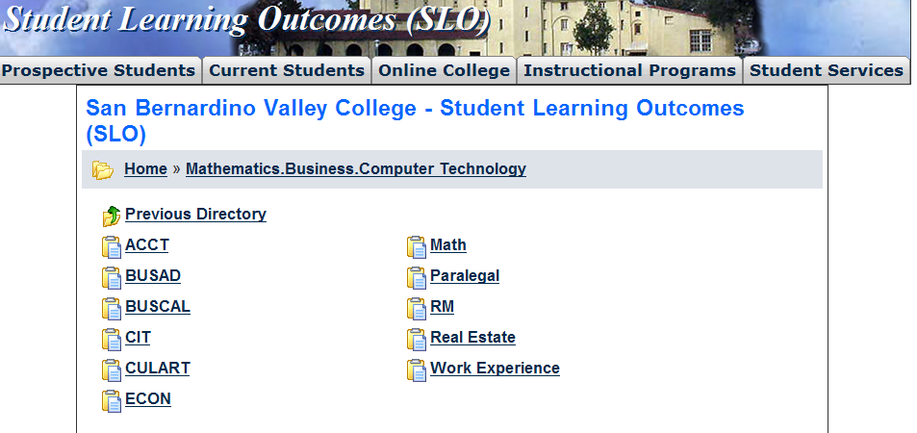
If you have courses for which SLOs have not been developed, explain why. What are your plans to remedy this?
No SLOs are here because they were not developed. There was no full-time faculty to develop SLOs. The current Department Head has begun developing SLOs and is collaborating with the current Adjunct faculty. SLOs for CS110 are currently submitted to the Division Dean

Attach your three-year plan for assessing SLOs.

What progress has the program made in its three-year plan? Have you implemented any program changes based on assessment results?

Development of a three-year plan at a time when the program is in such desperate need of support would be meaningless. SLOs must be developed first. There are courses for which there is no record of them being offered in several years. The plan is to first develop a coherent curriculum that aligns with contemporary Academic and Industry requirements. It is anticipated that this can be completed by the end of 2010. Then the courses will need to be written/updated. SLO creation/assessment plans will be part of the comprehensive program rehabilitation process and will be developed concurrently with the curriculum update.

Part III. Questions Related to Strategic Initiative: Institutional Effectiveness
Mission and Purpose
What is the purpose of the program?

The purpose of the program is to prepare San Bernardin Valley College students to enter the workforce as entry level software developers or other Computer Science related employment or to transfer with an appropriate academic preparation to a four-year Computer Science/Computer Technology program.

How does this purpose relate to the college mission?

This relates directly to the college mission in the area of providing quality education for a diverse community of learners.

Productivity
Provide additional analysis and explanation of the productivity data and narrative in the EMP Summary, if needed.
The productivity is down due to the absence of any full-time faculty support for this program. This program clearly demonstrates that it is not productive without the active involvement of at least one full-time faculty member.

Relevance and Currency, Articulation of Curriculum
If applicable to your area, describe your curriculum by answering the following questions.
Mathematics, Business & Computer Technology
Computer Science
 | Course | Status | Last Content Review | Next Review Date
 | CS098 Computer Science Work Experience | Active | 12/07/2009 | 12/07/2015
 | CS110 Fundamentals of Computer Science | Pending | 11/15/2004 | 11/15/2010
 | CS110 Fundamentals of Computer Science | Active | 11/15/2004 | 11/15/2010
 | CS120 Introduction to Visual Basic.NET | Active | 11/15/2003 | 11/15/2009
 | CS120 Introduction to Visual Basic.NET | Pending | 11/15/2003 | 11/15/2009
 | CS130 Applied Computer Logic | Active | 04/15/2000 | 04/15/2006
 | CS130 Applied Computer Logic | Pending | 04/15/2000 | 04/15/2006
 | CS150 Programming with Java | Pending | 11/15/2004 | 11/15/2010
 | CS165 Pascal Programming | Pending | 04/15/2000 | 04/15/2006
 | CS170 Assembly Language | Active | 04/15/2000 | 04/15/2006
 | CS190 Programming in C++ | Active | 04/15/2002 | 04/15/2008
 | CS190 Programming in C++ | Pending | 04/15/2002 | 04/15/2008
 | CS215 Programming with Java | Active | 11/15/2004 | 11/15/2010
 | CS220 Visual Basic Programming II | Historical | 04/15/2000 | 04/15/2006
 | CS220 Advanced Visual Basic.NET Programming | Active | 05/12/2008 | 05/12/2014
 | CS265 Data Structures | Active | 11/15/2005 | 11/15/2011
 | CS290 Data Structures Using C++ | Pending | 11/15/2005 | 11/15/2011

The Content Review Summary from Curricunet indicates the programs current curriculum status. If curriculum is out of date, explain the circumstances surrounding the error and plans to remedy the discrepancy.
The Curricunet report shows that curriculum update process for this discipline essentially stopped in 2004/2005 academic year. Clearly this is due to the absence of any full-time faculty support for this program. The plan is to have the one full-time faculty that has a current FSA for Computer Science to update the courses as they are taught. CS110 is now actively being updated.

Articulation
List Courses above 100 where articulation is not occurring | With CSU | With UC
The current state of Articulation is unknown. | Click here to enter text. | Click here to enter text.
Click here to enter text. | Click here to enter text. | Click here to enter text.
Click here to enter text. | Click here to enter text. | Click here to enter text.
Click here to enter text. | Click here to enter text. | Click here to enter text.

Describe your plan to articulate these classes.
The CS Department Head is actively working with CSUSB faculty to establish a transferrable course sequence. Following that work, the articulation agreements will be initiated.

Currency
Review the last college catalogue data given below.
COMPUTER SCIENCE  ASSOCIATE OF SCIENCE DEGREE  To graduate with a specialization in Computer Science  and intending to transfer to four-year institutions, students  must complete a total of 25-26 units listed below in  addition to general education requirements.  REQUIRED COURSES: UNITS  CS 110 Fundamentals of Computer Science 3  CS 190 Programming in C++ 4  CS 265 Data Structures 3  PHYSIC 200 General Physics I 6  PHYSIC 201 General Physics II 6  SELECT ONE OF THE FOLLOWING COURSES: 3-4  CS 130 Applied Computer Logic (3)  CS 170 Assembly Language (4)  CS 215 Programming with Java (4)  TOTAL UNITS: 25-26  COMPUTER SCIENCE CERTIFICATE  This certificate is designed to provide students with the  fundamentals of software engineering, information  processing concepts, and programming to prepare them  for entry-level positions as programmers for scientific and  business applications. In addition, this certificate  completes the lower division requirements of the certificate  program offered by the Computer Science Department at  CSU San Bernardino.  REQUIRED COURSES: UNITS  CS 110 Fundamentals of Computer Science 3  CIT 100 Introduction to Personal Computers 3  CS 120 Introduction to Visual Basic.NET 4  CS 220 Visual Basic.NET Programming II 3  SELECT ONE OF THE FOLLOWING COURSES:  CS 190 Programming in C++ (4)  CS 215 Programming with Java (4)  TOTAL UNITS: 17  COURSES OFFERED BY THE DEPARTMENT OF  COMPUTER SCIENCE:  CS 110  FUNDAMENTALS OF COMPUTER SCIENCE  3 UNITS  PREREQUISITE: MATH 095.  LECTURE: 2 contact hours per week and  LABORATORY: 3 contact hours per week.  An orientation in computer science for computer science  majors. Topics include an overview of the computer  discipline, the design and use of the computer devices, the  art of problem solving and programming, and the  representation of data. Includes hands-on experience in  computer programming using languages such as Visual  Basic.NET and C++.  Associate Degree Applicable  Course credit transfers to CSU and *UC. | INTRODUCTION TO VISUAL BASIC.NET  4 UNITS  PREREQUISITE: None.  LECTURE: 3 contact hours per week and  LABORATORY: 3 contact hours per week.  An introduction to a Web-based programming language,  Visual Basic.NET as it applies to scientific, business and  manufacturing settings. Topics include problem solving,  graphical user interface, program design, software tools,  structured logic, object-oriented programming, graphics  and animation, procedures, arrays, files, and Web  projects.  Associate Degree Applicable  Course credit transfers to CSU and UC.  CS 130  APPLIED COMPUTER LOGIC 3 UNITS  PREREQUISITE: CS 110.  LECTURE: 3 contact hours per week.  An introduction to digital systems. Topics include Boolean  algebra, truth tables, logic gates, number systems and  codes, Karnaugh maps, flip-flops, counters and registers,  digital arithmetic, combinatorial logic and functions.  Associate Degree Applicable  Course credit transfers to CSU and UC.  CS 170  ASSEMBLY LANGUAGE 4 UNITS  PREREQUISITE: CS 110.  LECTURE: 3 contact hours per week and  LABORATORY: 3 contact hours per week.  An introduction to assembly language and machine  organization. Topics include memory location, register  references, data definitions, machine instructions, screen  processing, disk storage and macros.  Associate Degree Applicable  Course credit transfers to CSU and UC.  CS 190  PROGRAMMING IN C++ 4 UNITS  PREREQUISITE: CS 110.  LECTURE: 3 contact hours per week and  LABORATORY: 3 contact hours per week  This course is an introduction to the object-oriented  language, C++. Topics include object-oriented design,  program logic structures, problem solving techniques,  arrays and records, procedures and functions, classes and  objects, pointers and references, inheritance, and  polymorphism.  Associate Degree Applicable  Course credit transfers to CSU and UC.  .

CS 198  COMPUTER SCIENCE WORK EXPERIENCE 1-4 UNITS  PREREQUISITE: None.  Supervised training in the form of on the job employment  that will enhance the student’s educational goals. The  student’s major and job must match. Students work 5-20  contact hours per week to earn units using the following  formula: For paid work, 75 hours = 1 unit; for volunteer  work, 60 hours = 1 unit. Students may earn a total of 16  units toward graduation in Work Experience 198 courses.  Students MUST be working for pay or volunteer before  registering for a Work Experience class. NOTE: Only one  section of Work Experience may be taken during a  semester.  Associate Degree Applicable  Course credit transfers to CSU for elective credit only  CS 215  PROGRAMMING WITH JAVA 4 UNITS  PREREQUISITE: CS 110.  LECTURE: 3 contact hours per week and  LABORATORY: 3 contact hours per week.  An introduction to the network-friendly language, Java.  Topics include object-oriented design, multiple platform  environment, program logic structures, graphical user  interface, Visual J++, Java Applet and recursion.  Associate Degree Applicable  Course credit transfers to CSU and UC.  CS 220  ADVANCED VISUAL BASIC.NET PROGRAMMING  4 UNITS  PREREQUISITE: CS 120.  LECTURE: 3 contact hours per week and  LABORATORY: 3 contact hours per week.  Advanced programming using Visual Basic .NET with  emphasis on software development and maintenance.  Topics include object-oriented design, multiple class  modules, interface and linking, windows and Internet  controls, and database access.  Associate Degree Applicable  Course credit transfers to CSU and UC. | CS 222  SPECIAL PROBLEMS IN COMPUTER SCIENCE I  1 UNIT  PREREQUISITE: CS 110.  INDEPENDENT STUDY: 3 contact hours per week.  Assigned problems involving computer laboratory work for  selected students who are interested in furthering their  knowledge of computer science on an independent study  basis. Students are required to devote three contact hours  per week to their project throughout the semester. Prior to  registration, a contract must be prepared.  See instructor for details.  Associate Degree Applicable  Course credit transfers to CSU.  Limited transfer to UC; credit determined after transfer to UC.  CS 265  DATA STRUCTURES 3 UNITS  PREREQUISITE: CS 190.  LECTURE: 2 contact hours per week and  LABORATORY: 3 contact hours per week.  An introduction to data structures such as linked lists,  stacks, queues and trees. Topics include algorithm  development, storage allocation, data organization,  information retrieval system software and language  support features.  Associate Degree Applicable  Course credit transfers to CSU and UC.

Which courses are no longer being offered? (Include Course # and Title of the Course)

The discipline is undergoing a complete overhaul. This information is not available at this time.
Click here to enter text.
Click here to enter text.
Click here to enter text.

Planning
What are the trends, external to the institution, impacting your student enrollment/service utilization? How will these trends impact program planning?
Clearly Computer Science is in a dynamic growing area of the global economy. The need for Information Technology workers according to the Bureau of Labor and Statistics 2008-2018 projections will increase by more than 50% with software publishing alone accounting for a 30% increase. Where will these workers come from? That software development is an international enterprise. Rapid and ubiquitous communications technologies have created a worldwide pool of talent that the largest corporate software developers draw upon. Yet time and again we see that the breakthrough technologies are developed in nimble entrepreneurial start-ups not corporate behemoths. This global environment drives three imperatives that we must address as we prepare our students to compete. The first is that we must equip them with a firm foundation in the fundamentals of Computer Science. The rate of change in this field is astonishing. The new technologies are created by those that can innovate upon the foundation of established principles. As in all sciences, we stand upon the shoulders of giants. If not in college, where will they gain this understanding? The second is that we must prepare them with an appreciation of the implications of the interconnected world in which we live both from the perspective of overwhelming technical challenges such as security and from the perspective of how the technology interacts with individuals, groups, nations, and the global human society. Finally we must prepare them to be entrepreneurs. This will prepare them to compete in a global environment.

Accomplishments and Strengths
Referencing the narratives in the EMP Summary, provide any additional data or new information regarding the accomplishments of the program, if applicable. In what way does your planning address accomplishments and strengths in the program?

There are few if any accomplishments for this program since it lost its only full-time faculty. The strength may be that it somehow managed to survive and somehow students still enrolled in courses for a program that has awarded only a single degree in four years. Compare this with the 22 degrees and 4 certificates awarded in 2004/2005. The plans address a radical update approaching a complete overhaul of the program. The complete lack of Accomplishments and strengths clearly require this action.

Weaknesses
Referencing the narratives in the EMP Summary, provide any additional data or new information regarding planning for the program. In what way does your planning address trends and weaknesses in the program?
The weaknesses are abundant. There are significant and troubling discrepancies in the area of student demographics. There are weaknesses in terms of retention, enrollment, productivity, degree/certificate completion and just about any measure that might be used to measure a program. The plan is to completely rebuild the program. This is radical but the current program performance clearly indicates the need for this.

V. Questions Related to Strategic Initiative: Technology, Campus Climate and Partnerships.

Describe how your program has addressed the strategic initiatives of technology, campus climate and/or partnerships.
The program has barely survived. It has not addressed any areas listed above. This is something that will be required to be addressed in the planning process

